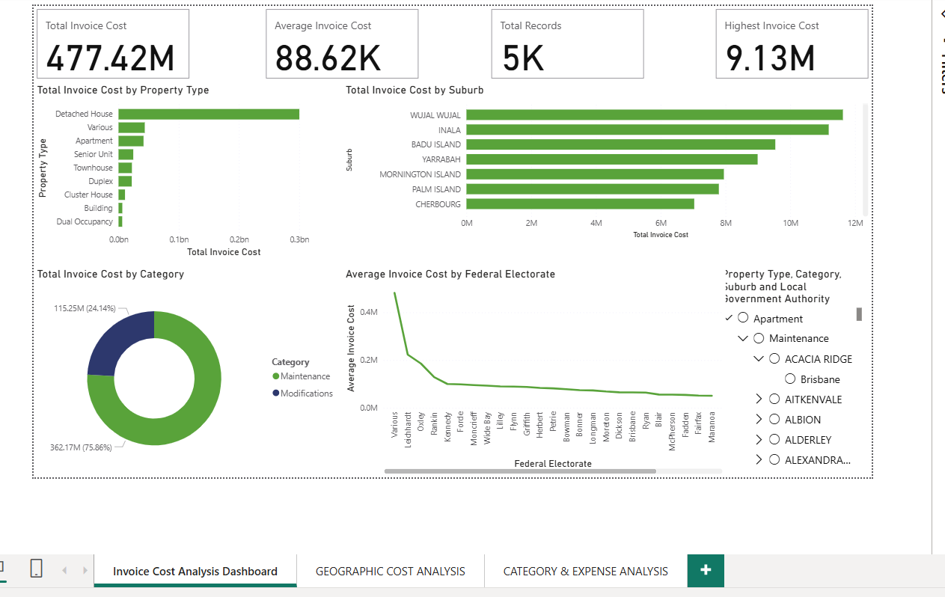
Invoice Cost Analysis Dashboard – Detailed Explanation
1. Dashboard Objective
This dashboard provides a high-level financial overview of invoice costs across properties, locations, and expense categories. It is designed to give decision-makers immediate visibility into total spending, cost drivers, and distribution patterns, enabling informed financial and operational decisions.

2. Executive Summary Indicators (Top KPIs)
At the top of the dashboard, four key performance indicators summarize the entire dataset:
🔹 Total Invoice Cost – 477.42M
- Represents the overall expenditure recorded in the dataset.
- Acts as the primary financial benchmark for all analysis.
- Helps stakeholders instantly understand the scale of spending.
🔹 Average Invoice Cost – 88.62K
- Shows the typical invoice value across all records.
- Useful for identifying whether individual invoices are generally high or low.
- Supports budgeting and forecasting discussions.
🔹 Total Records – 5K
- Indicates the total number of invoice entries analyzed.
- Provides transparency on data volume and reliability.
🔹 Highest Invoice Cost – 9.13M
- Highlights the largest single invoice value.
- Useful for identifying exceptional or high-impact transactions that may require further review.

3. Invoice Cost by Property Type (Top Left)
This visual compares total invoice cost across different property types.
Key Insights:
- Detached Houses contribute the largest share of total costs, indicating they are the most cost-intensive property type.
- Other property types such as Apartments, Townhouses, Duplexes, and Cluster Houses show significantly lower cost contributions.
- This helps identify which asset types are driving the majority of expenditure.
Business Value:
- Supports asset management and maintenance planning.
- Enables prioritization of high-cost property types for cost optimization strategies.

4. Invoice Cost by Suburb (Top Right)
This bar chart ranks suburbs based on total invoice cost.
Key Insights:
- Certain suburbs (e.g., Wujal Wujal, Inala, Badu Island) clearly stand out as cost hotspots.
- The ranking makes it easy to identify geographic concentration of spending.
- Enables comparison between high-cost and lower-cost areas.
Business Value:
- Supports location-based budgeting and regional cost control.
- Helps decision-makers focus attention on areas with the greatest financial impact.

5. Invoice Cost by Category (Bottom Left)
This donut chart shows the distribution of total costs by expense category.
Key Insights:
- Maintenance accounts for approximately 75.86% of total invoice costs.
- Modifications contribute around 24.14%.
- This indicates that routine maintenance is the dominant cost driver.
Business Value:
- Helps finance and operations teams understand where money is being spent.
- Supports evaluation of whether spending patterns align with organizational priorities.

6. Average Invoice Cost by Federal Electorate (Bottom Center)
This line chart displays how average invoice costs vary across federal electorates.
Key Insights:
- There is a noticeable variation in average costs between electorates.
- Some electorates have significantly higher average invoice values, indicating more expensive or complex activities.
- Others show lower averages, suggesting more routine or smaller-scale expenditure.
Business Value:
- Supports governance, reporting, and accountability requirements.
- Enables comparison of spending efficiency across administrative regions.

7. Interactive Filtering & Drill Capability (Right Panel)
The dashboard includes hierarchical slicers that allow users to filter data by:
- Property Type
- Category
- Suburb
- Local Government Authority
Business Value:
- Enables users to explore data dynamically without technical expertise.
- Allows focused analysis for specific locations, asset types, or expense categories.
- Enhances usability for both executive and operational users.

8. Overall Value to the Client
This dashboard delivers:
- Immediate financial visibility
- Clear identification of major cost drivers
- Geographic and asset-level insights
- Support for strategic planning and budget optimization
- Reduced reliance on manual reporting

9. Executive-Level Summary Statement
This dashboard provides a consolidated view of invoice costs across properties, locations, and expense categories, enabling stakeholders to monitor spending patterns, identify high-impact cost drivers, and support data-driven financial decision-making.

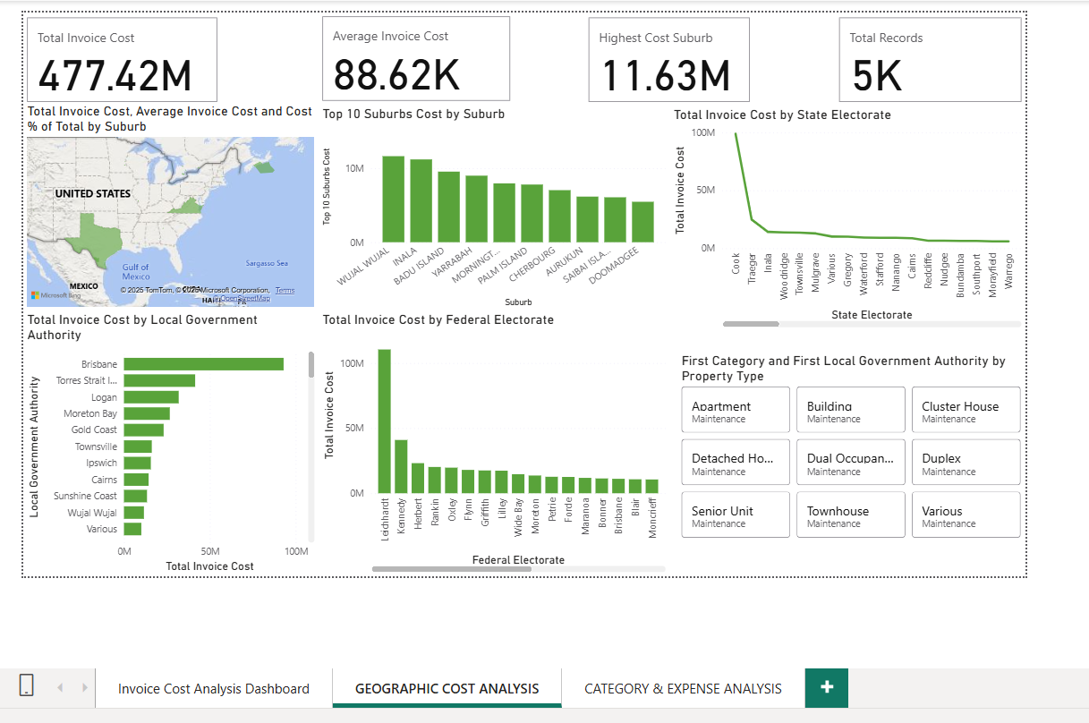
Geographic Cost Analysis Dashboard – Detailed Explanation
1. Dashboard Purpose
This dashboard focuses on where invoice costs are occurring geographically.
It enables stakeholders to identify high-cost locations, compare regions, and understand geographic spending concentration across multiple administrative levels.

2. Executive Summary Indicators (Top KPIs)
🔹 Total Invoice Cost – 477.42M
- Represents the overall spending captured in the dataset.
- Serves as the baseline reference for all geographic comparisons.
🔹 Average Invoice Cost – 88.62K
- Shows the typical invoice value across all locations.
- Useful for understanding average spending intensity per transaction.
🔹 Highest Cost Suburb – 11.63M
- Identifies the single suburb with the highest total invoice cost.
- Highlights a critical geographic cost hotspot requiring attention.
🔹 Total Records – 5K
- Indicates the total number of invoice records included in the analysis.
- Confirms the robustness and reliability of the insights.

3. Geographic Distribution Map (Top Left)
What It Shows
- A map visual displaying total invoice cost, average invoice cost, and percentage contribution by suburb.
- Darker or larger markers represent higher cost concentrations.
Business Insight
- Quickly reveals regional clusters of high spending.
- Allows stakeholders to visually identify geographic cost patterns rather than relying on tables.

4. Top 10 Suburbs by Total Invoice Cost (Top Center)
What It Shows
- A ranked comparison of the 10 highest-cost suburbs.
- Suburbs such as Wujal Wujal, Inala, and Badu Island emerge as dominant cost drivers.
Business Insight
- Highlights priority locations for cost review, audits, or targeted intervention.
- Helps leadership focus on a manageable set of high-impact areas.

5. Total Invoice Cost by State Electorate (Top Right)
What It Shows
- Aggregates total costs by state electorate boundaries.
- Displays clear variation in spending across electorates.
Business Insight
- Supports state-level governance and reporting.
- Enables comparison of spending distribution aligned with political or administrative regions.

6. Total Invoice Cost by Local Government Authority (Bottom Left)
What It Shows
- Ranks Local Government Authorities (LGAs) by total invoice cost.
- LGAs such as Brisbane and Torres Strait Island show significantly higher expenditure.
Business Insight
- Helps identify which councils or authorities are managing the highest costs.
- Supports inter-government coordination and funding allocation decisions.

7. Total Invoice Cost by Federal Electorate (Bottom Center)
What It Shows
- Compares invoice costs across federal electorates.
- Reveals substantial cost variation between electorates.
Business Insight
- Enables federal-level oversight and accountability.
- Useful for reporting to stakeholders concerned with national or parliamentary regions.

8. Property Type Summary (Bottom Right)
What It Shows
- Displays the primary expense category and local government authority associated with each property type.
- Indicates that Maintenance is the dominant expense across all property types.
Business Insight
- Confirms consistency in cost drivers across property categories.
- Reinforces maintenance as the primary focus area for cost optimization.

9. Interactivity & User Control
The dashboard supports interactive exploration through:
- Geographic filtering
- Property type selection
- Category-based slicing
- Administrative region drill-down
This allows users to move from high-level geographic insight to detailed regional analysis without technical complexity.

10. Overall Value to the Client
This dashboard enables the client to:
- Identify geographic cost hotspots
- Compare spending across suburbs, LGAs, and electorates
- Support governance and compliance reporting
- Prioritize regions for cost control initiatives
- Improve transparency and accountability

11. Executive Summary Statement
This geographic cost analysis dashboard provides a comprehensive view of where invoice costs are concentrated, enabling informed location-based decision-making, effective budget allocation, and improved cost governance.

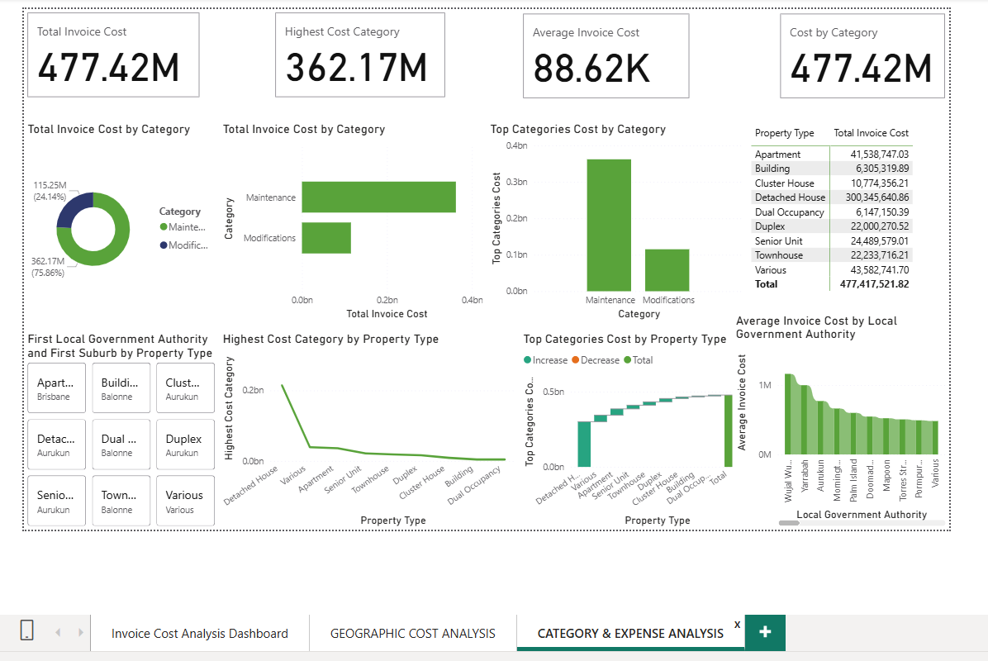
Category & Expense Analysis Dashboard – Detailed Explanation
1. Dashboard Purpose
This dashboard focuses on how invoice costs are distributed by expense category and property type. It helps decision-makers understand what type of work is driving costs, which property types are most expensive, and where cost optimization efforts should be focused.

2. Key Performance Indicators (Top Section)
🔹 Total Invoice Cost – 477.42M
- Represents the total expenditure across all invoice records.
- Acts as the benchmark for evaluating category-wise and property-wise spending.
🔹 Highest Cost Category – 362.17M
- Identifies the most expensive expense category, which is Maintenance.
- Indicates that maintenance activities account for the majority of overall costs.
🔹 Average Invoice Cost – 88.62K
- Shows the average cost per invoice across all categories.
- Helps assess whether individual invoices are generally high-value or low-value.
🔹 Cost by Category – 477.42M
- Confirms that all categories together reconcile with the total invoice cost.
- Ensures data consistency and accuracy.

3. Total Invoice Cost by Category (Donut Chart)
What It Shows
- Visual breakdown of costs between:
  - Maintenance (362.17M – 75.86%)
  - Modifications (115.25M – 24.14%)
Business Insight
- Maintenance dominates spending, consuming over three-quarters of total costs.
- Modifications, while fewer, still represent a significant investment area.

4. Total Invoice Cost by Category (Bar Chart)
What It Shows
- A direct comparison of total costs for each category.
- Reinforces that Maintenance costs are more than three times higher than Modifications.
Business Insight
- Provides a clear justification for prioritizing maintenance cost control strategies.

5. Top Categories Cost by Category
What It Shows
- Highlights the absolute cost contribution of each category.
- Maintenance stands out as the primary cost driver.
Business Insight
- Confirms that cost reduction initiatives in Maintenance will have the largest financial impact.

6. Property Type Cost Summary Table (Top Right)
What It Shows
- Displays total invoice cost by property type, including:
  - Detached House – 300.35M
  - Apartment – 41.54M
  - Townhouse – 22.23M
  - Senior Unit – 24.49M
  - Other property types with smaller contributions
Business Insight
- Detached Houses are the most expensive property type, accounting for the majority of spending.
- Provides data-driven justification for targeted property-specific budgeting.

7. First Local Government Authority & Suburb by Property Type (Bottom Left)
What It Shows
- Identifies the first recorded Local Government Authority and suburb associated with each property type.
Business Insight
- Helps establish geographic reference points for property categories.
- Useful for contextual analysis and data validation.

8. Highest Cost Category by Property Type (Line Chart)
What It Shows
- Shows the highest cost category associated with each property type.
- Detached Houses show the highest maintenance cost spike.
Business Insight
- Confirms that maintenance costs are highest for Detached Houses, reinforcing their role as a major cost driver.

9. Top Categories Cost by Property Type (Waterfall Chart)
What It Shows
- Displays how different property types contribute incrementally to total category costs.
- Shows increases and the final cumulative total.
Business Insight
- Helps stakeholders understand how each property type builds up the total expenditure.
- Supports transparent cost composition analysis.

10. Average Invoice Cost by Local Government Authority (Bottom Right)
What It Shows
- Ranks Local Government Authorities by average invoice cost.
- Authorities like Wujal Wujal and Yarrabah show higher average costs per invoice.
Business Insight
- Highlights regions where individual invoices are significantly higher, even if total volume is lower.
- Useful for audit, pricing review, or contractor performance assessment.

11. Interactivity & Analytical Flexibility
The dashboard supports:
- Filtering by property type
- Category-level analysis
- Local Government Authority comparisons
This enables users to drill down from high-level spending to specific operational insights.

12. Overall Value
This dashboard empowers the client to:
- Identify major cost drivers by category
- Understand property-specific spending patterns
- Prioritize maintenance cost optimization
- Support budget planning and forecasting
- Improve financial governance and transparency

13. Executive Summary Statement
The Category & Expense Analysis Dashboard provides a comprehensive view of how invoice costs are distributed across expense categories and property types, enabling informed financial planning, targeted cost control, and improved operational decision-making.

